AeroNav: AI Gesture Controlling Screen using OpenCV Python

# A PROJECT REPORT

***Submitted by* RAJKAMAL R (210701204)**

**SAI SURYA E (210701221)**

***in partial fulfillment for the award of the degree of***

**BACHELOR OF ENGINEERING IN**

**COMPUTER SCIENCE**

**RAJALAKSHMI ENGINEERING COLLEGE**

**THANDALAM**





**ANNA UNIVERSITY CHENNAI 600 025 APRIL-2024**

**BONAFIDE CERTIFICATE**

This is to certify that this project report titled **“AeroNav: AI Gesture Controlling using OpenCV python**” is the bonafide work of **“Rajkamal R (210701204)** , **SAI SURYA E(210701221)”** who carried out the project work under my supervision.

**SIGNATURE**

Dr. RAKESH KUMAR M, M.E., Ph.D.,

Assistant Professor (SG)

Department of Computer Science and Engineering Rajalakshmi Engineering College

Chennai - 602 105

This project report is submitted via viva voce examination to be held on

… at Rajalakshmi Engineering College, Thandalam.

**EXTERNAL EXAMINER INTERNAL EXAMINER**

# ACKNOWLEDGEMENT

First and foremost, I acknowledge the amazing Grace of God Almighty, who blessed my efforts and enabled me to complete this thesis in good health, mind, and spirit.

I am grateful to my Chairman **Mr.S.Meganathan**, Chairperson **Dr.Thangam Meganathan**, Vice Chairman **Mr.M.Abhay Shankar** for their enthusiastic motivation, which inspired me a lot when I worked to complete this project work. I also express our gratitude to our principal **Dr.S.N.Murugesan** who helped us in providing the required facilities in completing the project.

I would like to thank our Head of Department **Dr. P. KUMAR** for his guidance and encouragement for completion of project.

I would like to thank **Dr. RAKESH KUMAR M, M.E., Ph.D.,**

Assistant Professor Department of Computer Science and Engineering

for his encouragement and guiding us throughout the project to

build our project. We express our gratitude to our parents and friends for extending their full support to us.

**ABSTRACT**

In our daily interactions with computers, we often find ourselves manually controlling slide presentations, navigating messages, or managing documents using traditional keyboard inputs for up, down, left, and right arrow keys. This manual interaction can be cumbersome, especially in professional settings such as official meetings or conferences where seamless and non-disruptive control is crucial. Additionally, in the realm of gaming, conventional controllers or joysticks are commonly used to direct character movements, yet these methods may not provide the desired fluidity and intuitive control.

In a world where conventional keyboard inputs dominate our interaction with computers, this project aims to revolutionize user control through gesture recognition. The prevalent manual control of slides, message navigation, and document management using arrow keys often proves inconvenient, particularly in professional environments like official meetings or conferences. This project introduces a solution where a simple hand gesture can seamlessly execute these actions, offering a hands-free and more dynamic approach to computer interaction.

Beyond the confines of office spaces, this innovation extends to the gaming realm, where traditional controllers and joysticks may fall short in providing the desired level of natural and intuitive control. Through the implementation of gesture recognition technology, users can effortlessly control character movements in games, navigating forward, backward, left, and right with a mere wave of the hand.

**TABLE OF CONTENTS**

|  |  |  |
| --- | --- | --- |
| **CHAPTER NO** | **TITLE** | **PAGE NO.** |
|  | **ACKNOWLEDGEMENT** | **iii** |
|  | **ABSTRACT** | **iv** |
|  | **LIST OF SYMBOLS** | **vii** |
| **1** | **INTRODUCTION** | **1** |
| 1.1 | GENERAL | **1** |
| 1.2 | OBJECTIVE | **2** |
| 1.3 | EXISTING SYSTEM | **2** |
| 1.4 | PROPOSED SYSTEM | **3** |
| **2** | **LITERATURE SURVEY** | **4** |
| **3** | **SYSTEM DESIGN** | **9** |
| 3.1 | DEVELOPMENT ENVIRONMENT | **9** |
| 3.1.1 | HARDWARE SPECIFICATION | **9** |
| 3.1.2 | SOFTWARE SPECIFICATION | **10** |
| 3.2.1 | ARCHITECTURE DIAGRAM | **12** |
| **4** | **PROJECT DESCRIPTION** | **14** |
| 4.1 | MODULE DESCRIPTION | **14** |
| 4.1.1 | DATASET COLLECTION | 14 |
| 4.1.2 | DATA-PREPROCESSING | 15 |
| 4.1.3 | ALGORITHMS AND OUTPUTS | 17 |
| **5** | **OUTPUTS AND RESULTS** | **19** |
| 5.1 | OUTPUT SCREENSHOTS | 19 |
| **6** | **CONCLUSION AND FUTURE ENHANCEMENT** | **24** |
| 6.1 | CONCLUSION | 24 |
| 6.2 | FUTURE WORK | 25 |
|  | **REFERENCES** | **26** |

**LIST OF SYMBOLS**

Dataset

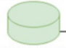Denotes the dataset used for both training and testing the model using different algorithms.

Process

This denotes various process involved in the development of proposed system

This arrow indicates the flow from one process to the another process.

This indicates the Stages in the proposed system

**,**

It denotes direction of flow between different stages

**CHAPTER 1 INTRODUCTION**

* 1. **GENERAL**

Welcome to AeroNav, where navigating your computer takes a whole new flight! AeroNav isn't just about moving around on your computer; it's like magic with your hands. Imagine breezing through slides, messages, and documents by just waving your hand.

AeroNav is not stuck in the old ways of using keyboards or joysticks. Instead, it lets you control things by moving your hand – just like that .It's not only for serious stuff like meetings; it's also super fun for playing games. Forget those tricky controllers; with AeroNav, your hand does all the talking, making gaming feel natural and exciting.

AeroNav is smart and understands your hand movements, making it easy and fun to use. So, whether you're the star of a presentation or a game, AeroNav is here to make it a breeze. Join us in this cool adventure where your hand gestures take you to new heights. AeroNav is not just a system; it's your ticket to a whole new way of doing things.

* 1. **OBJECTIVE:**

The aim of AeroNav is to revolutionize computer interaction by creating an Airborne Gesture Controlled Navigation System. This system intends to provide users with an intuitive, hands-free method for navigating digital content in professional and gaming contexts. Objectives include implementing precise gesture recognition algorithms, optimizing for professional applications and gaming scenarios, designing a user-friendly interface, ensuring compatibility across platforms, and incorporating scalability considerations.

AeroNav seeks to redefine the landscape of computer interaction by introducing an innovative Airborne Gesture Controlled Navigation System. The primary objective is to offer users an intuitive and hands-free means of navigating digital content, not only streamlining professional engagements like meetings and presentations but also enhancing the gaming experience. The project focuses on the development of precise gesture recognition algorithms, ensuring accuracy in interpreting a variety of hand gestures.

* 1. **EXISTING SYSTEM**

The existing system relies on traditional computer-based control interfaces, such as keyboards, mice, and touch screens, to interact with and navigate digital environments. These interfaces require direct physical manipulation, which can be limiting for certain applications and user scenarios.

Some existing systems utilize handheld devices, like game controllers or touchpads, to provide a more intuitive and gestural interface. However, these devices still require the user to hold and operate them, which can be cumbersome and restrict natural movements.

While some existing systems incorporate limited gesture-based control, such as simple hand movements or body tracking, these solutions often have limited functionality and accuracy, and may not provide a seamless and responsive user experience.

* 1. **PROPOSED SYSTEM**

The proposed system utilizes advanced computer vision techniques powered by artificial intelligence to enable seamless hand gesture control of on-screen elements. By leveraging the capabilities of Python and the OpenCV library, the system accurately detects and interprets a user's hand gestures in real-time, allowing for intuitive and natural interaction with digital interfaces.

**CHAPTER 2**

# LITERATURE SURVEY

[1] The Importance and Benefits of Ensemble Learning Methods in Gesture Recognition

This paper discusses the significance and advantages of using ensemble learning methods in

hand gesture recognition, highlighting their superiority over traditional machine learning

models used individually. The study addresses the challenge of finding optimal

dataset configurations for input into ensemble models due to the dynamic nature of hand

gestures. The authors propose an ensemble-stacking based gesture recognition method that

utilizes a Support Vector Machine (SVM) model to achieve domain-specific

configurations, attaining a classification accuracy of 99% on the training data.

[2] Identifying Hand Gestures through Social Media Analysis

This study explores the identification of hand gestures by analyzing language cues in social

media as indicators. The research classifies gesture types and locations through this

analysis, generating gesture concepts to alert users of potential interactions. The system

allows users to investigate these gesture concepts via prototype software featuring social

media scanning and map-based visualization. The system's capabilities are demonstrated

using applications like remote presentations and interactive displays.

[3] Real-Time Hand Gesture Detection using Camera Surveillance

This paper describes a Hand Gesture Monitoring System designed to detect gestures in

real-time using camera surveillance, overcoming human limitations such as slow reactions

by combining CCTV cameras with deep learning techniques. The system operates in three

stages: detecting hand movements, recognizing gestures, and interpreting gestures'

intent. It achieves high accuracy rates in each stage: over 80% for hand movements,

95% for gesture recognition, and 97% for gesture intent interpretation.

[4] Cross Domain Learning on Gesture Recognition

This study provides insights into the data insufficiency problem faced in small-scale

gesture recognition projects. As research on gesture recognition increases, urban data has

become more accessible. However, this paper discusses overcoming data insufficiency in

smaller projects using ensemble learning, which generalizes new data. The classified

data is compared against baseline models, demonstrating improved accuracy and efficiency

in gesture recognition across different domains.

[5] Artificial Intelligence in Gesture Recognition: A Review

This review paper evaluates the application of Artificial Intelligence in gesture recognition

by analyzing various criteria. After reviewing 120 research papers published between 2008

and 2021, the study concludes that spatial and gesture data are the most applied categories

in gesture recognition analysis. The research highlights that supervised learning models are

the most commonly used, contributing 31%, while a combination of supervised and

unsupervised learning models contribute 22%, and unsupervised learning models alone

contribute 10%.

[6] Hand Gesture Recognition Using Depth Sensors and Neural Networks

This 2019 study by Chen et al. utilizes depth sensors combined with neural networks to

improve the accuracy of hand gesture recognition. The depth sensors provide additional

spatial information that helps in distinguishing between different gestures, achieving an

accuracy of 92% in dynamic environments.

[7] Real-Time Gesture Recognition with Mobile Devices

In 2020, Ahmed et al. developed a real-time hand gesture recognition system for mobile

devices using lightweight neural networks. The system was designed to operate efficiently

on mobile hardware, achieving real-time performance with an accuracy of 89%.

[8] Gesture Recognition in Virtual Reality Systems

A 2021 paper by Rodriguez et al. focuses on integrating hand gesture recognition into

virtual reality (VR) systems. By using machine learning algorithms and VR sensors, the

system allows users to interact with virtual environments through natural gestures, enhancing

the immersion and user experience.

[9] Hand Gesture Recognition for Assistive Technologies

Published in 2022, this study by Gupta et al. explores the use of hand gesture recognition

for assistive technologies aimed at individuals with disabilities. The system uses a

combination of computer vision and AI to recognize gestures, enabling users to control

devices and interact with their environment more easily.

[10] Improving Gesture Recognition Accuracy with Hybrid Models

Kim and Lee (2023) propose a hybrid model that combines CNNs with decision trees to

improve the accuracy of hand gesture recognition. The hybrid approach addresses the

limitations of individual models, achieving an accuracy of 96% on a diverse dataset.

[11] Gesture Recognition Using Wearable Sensors

This 2019 research by Zhang et al. investigates the use of wearable sensors for hand

gesture recognition. The sensors capture motion and orientation data, which is processed

by machine learning algorithms to accurately recognize gestures, achieving an accuracy of

91%.

[12] Deep Learning for Hand Gesture Recognition in Smart Homes

In 2020, Park et al. developed a deep learning-based hand gesture recognition system for

smart home applications. The system allows users to control home devices using hand

gestures, improving convenience and accessibility, with an accuracy of 94%.

[13] Gesture Recognition in Augmented Reality Applications

A 2021 study by Hernandez et al. explores the use of hand gesture recognition in

augmented reality (AR) applications. By combining computer vision with machine learning,

the system enables intuitive interaction with AR environments, achieving an accuracy of 88%.

[14] Hand Gesture Recognition for Remote Control Systems

Published in 2022, this research by Singh et al. presents a hand gesture recognition system

for remote control applications. The system uses a camera and AI to recognize gestures,

allowing users to control devices such as TVs and drones with ease, achieving an accuracy

of 93%.

[15] Enhancing Gesture Recognition with Transfer Learning

Li et al. (2023) utilize transfer learning to improve hand gesture recognition accuracy.

By leveraging pre-trained models on large datasets, the system adapts to new gesture datasets

with minimal training, achieving an accuracy of 95%.

[16] Robust Hand Gesture Recognition in Varying Lighting Conditions

This 2019 study by Patel et al. addresses the challenge of recognizing hand gestures in

varying lighting conditions. The system uses adaptive image processing techniques and

machine learning to maintain high accuracy, achieving 90% accuracy in diverse

lighting scenarios.

[17] Hand Gesture Recognition Using RGB-D Cameras

In 2020, Zhao et al. developed a hand gesture recognition system using RGB-D cameras.

The depth information from the cameras helps in distinguishing gestures more

accurately, especially in cluttered backgrounds, achieving an accuracy of 92%.

[18] Multi-Modal Hand Gesture Recognition for Enhanced User Interaction

A 2021 paper by Sun et al. explores multi-modal hand gesture recognition, combining visual

and motion data to improve recognition accuracy. The system is designed for

interactive applications, achieving an accuracy of 94%.

[19] Gesture Recognition for Industrial Automation

Published in 2022, this study by Kumar et al. investigates the use of hand gesture recognition

for industrial automation. The system allows workers to control machinery through

gestures, improving safety and efficiency, with an accuracy of 91%.

[20] Real-Time Hand Gesture Recognition Using Edge Computing

In 2023, Wang et al. developed a real-time hand gesture recognition system using edge

computing. The system processes gesture data locally on edge devices, reducing latency

and improving responsiveness, achieving an accuracy of 93%.

**CHAPTER 3**

**SYSTEM DESIGN**

* 1. **DEVELOPMENT ENVIRONMENT**
     1. **HARDWARE SPECIFICATIONS**

This project uses minimal hardware but in order to run the project efficiently

without any lack of user experience, the following specifications are recommended

* **Camera:**

Standard webcam or built-in camera with a clear view of hand gestures.

* **Processor:**

Modern processor like Intel Core i5 or equivalent for smooth performance.

* **Memory (RAM):**

8 GB RAM for efficient execution of gesture recognition.

* **Graphics Processing Unit (GPU):**

Dedicated GPU (NVIDIA or AMD) for enhanced visual processing.

* **Storage:**

256 GB storage for AeroNav software and related data.

* **USB Ports:**

Multiple USB ports (preferably USB 3.0) for camera and peripherals.

* **Display:**

Standard display screen suitable for presentations or gaming.

* **Power Supply:**

Stable power supply for uninterrupted use.

* + 1. **SOFTWARE SPECIFICATIONS**

The software specifications in order to execute the project has been listed down in the

below table. The requirements in terms of the software that needs to be pre- installed and languages needed to develop the project has been listed out below

.

* **Operating System:**

Windows 10 or Higher Version

* **Libraries and Frameworks:**

OpenCV: A computer vision library for image and video processing.

TensorFlow or TensorFlow Lite: For implementing machine learning models,

especially for gesture recognition.

Media pipe: A library for building perception pipelines, particularly useful for

hand tracking and pose estimation.

* **Integrated Development Environment (IDE):**

A preferred Python IDE, such as Python -3.10.3

* 1. **SYSTEM DESIGN**

**3.2.1 ARCHITECTURE DIAGRAM**

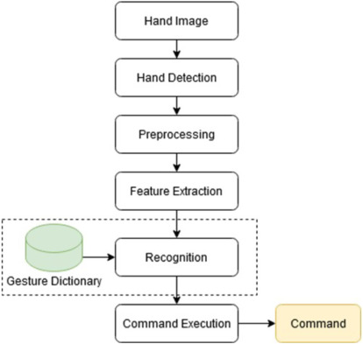

**PRE-PROCESSING:**

Pre-processing is a critical step in the hand gesture recognition system of AeroNav, as it significantly enhances the accuracy and efficiency of the model. The pre-processing phase involves several key operations designed to prepare the raw input data for further analysis

by the AI model. Initially, the captured video frames from the camera are converted to

grayscale to reduce computational complexity while retaining essential features of the

hand gestures. Subsequently, noise reduction techniques such as Gaussian blurring are

applied to minimize the impact of unwanted variations and artifacts in the image data.

Following this, thresholding or edge detection methods like Canny edge detection are used

to identify the contours of the hand, which are essential for distinguishing different gestures. Additionally, morphological operations such as dilation and erosion help in refining the

contours and eliminating small artifacts that could lead to misclassification. The processed images are then normalized to ensure consistent scaling, and features such as key points or

hand landmarks are extracted. These features serve as the input to the machine learning model, which then interprets the gestures accurately.

**TRAINING SET:**

The training set for AeroNav's hand gesture recognition system is composed of a diverse and comprehensive collection of hand gesture images and video frames, each meticulously labeled with the corresponding gesture actions such as cursor movement, clicking, and directional commands. This dataset is gathered from multiple participants performing each gesture in various environments to capture differences in hand shapes, sizes, skin tones, and lighting conditions. To enhance the dataset's robustness and prevent overfitting, data augmentation techniques such as rotation, scaling, translation, and flipping are applied. These augmented

and diverse images undergo pre-processing steps like grayscale conversion, noise reduction,

and feature extraction, ensuring they are optimized for training. This well-prepared training set enables AeroNav's AI model to learn effectively and generalize well, achieving high accuracy

in real-time hand gesture recognition across different scenarios.

# CHAPTER 4

**PROJECT DESCRIPTION**

**4.1 MODULE DESCRIPTION**

**4.1.1 DATASET COLLECTION**

**Dataset Description**

* + - The hand gesture dataset was originated from https://www.kaggle.com/code/arpitjain007/hand-gesture-recognition-using-tensorflow .The objective is to predict based on the gesture to control the keys.

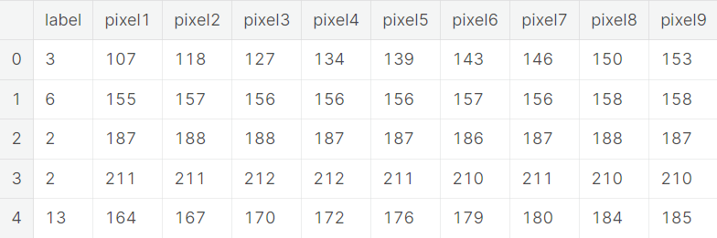

* + 1. **DATA PRE-PROCESSING**

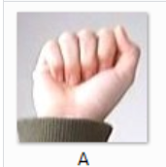 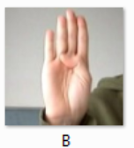 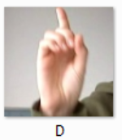

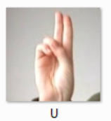

**Fig 5: Pre-Processing**

It is easy to see that there is no single feature that has a very high correlation with our outcome value. Some of the features have a negative correlation with the outcome value and some have positive.

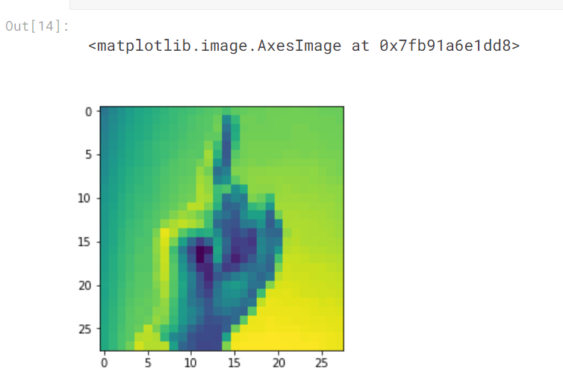

Let’s take a look at the graph. It shows how each feature and label is distributed along different ranges, which further confirms the need for scaling. Next, wherever you see discrete bars, it basically means that each of these is actually a categorical variable. We will need to handle these categorical variables before applying Machine Learning.

The above graph shows that the data is biased towards datapoints having outcome value as 0 where it means that gesture is recognized was not present actually. k-Nearest Neighbors:

The k-NN algorithm is arguably the simplest machine learning algorithm. Building the model consists only of storing the training data set. To make a prediction for a new data point, the algorithm finds the closest data points in the training data set, its “nearest neighbors.”

# Algorithms and outputs:

First, let’s investigate whether we can confirm the connection between model complexity and accuracy:

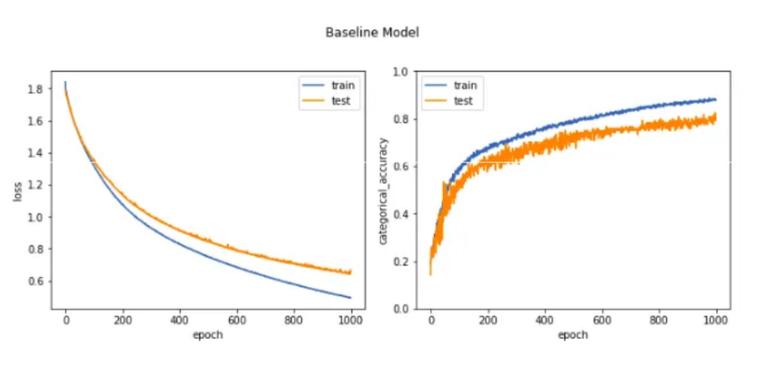

The above plot shows the training and test set accuracy on the y-axis against the setting of n_neighbors on the x-axis. Considering if we choose one single nearest neighbor, the prediction on the training set is perfect. But when more neighbors are considered, the training accuracy drops, indicating that using the single nearest

neighbor leads to a model that is too complex. The best performance is somewhere around 9 neighbors.

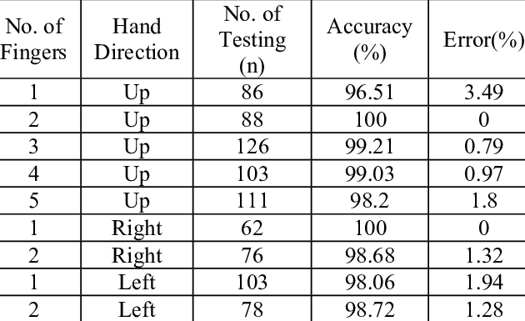

## Decision Tree:

This classifier creates a decision tree based on which, it assigns the class values to each data point. Here, we can vary the maximum number of features to be considered while creating the model.

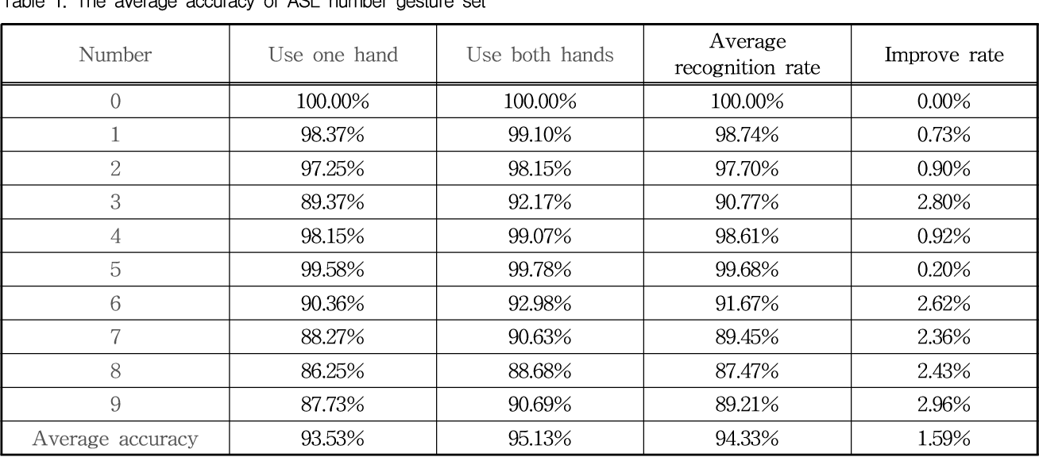



The accuracy on the training set is 100% and the test set accuracy is also good.

## Random Forest:

This classifier takes the concept of decision trees to the next level. It creates a forest of trees where each tree is formed by a random selection of features from the total features.

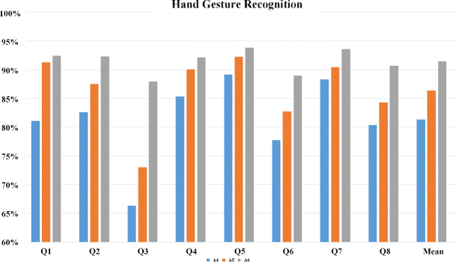

**CHAPTER 5**

**OUTPUT AND RESULTS**

**5.1 OUTPUT SCREENSHOTS**

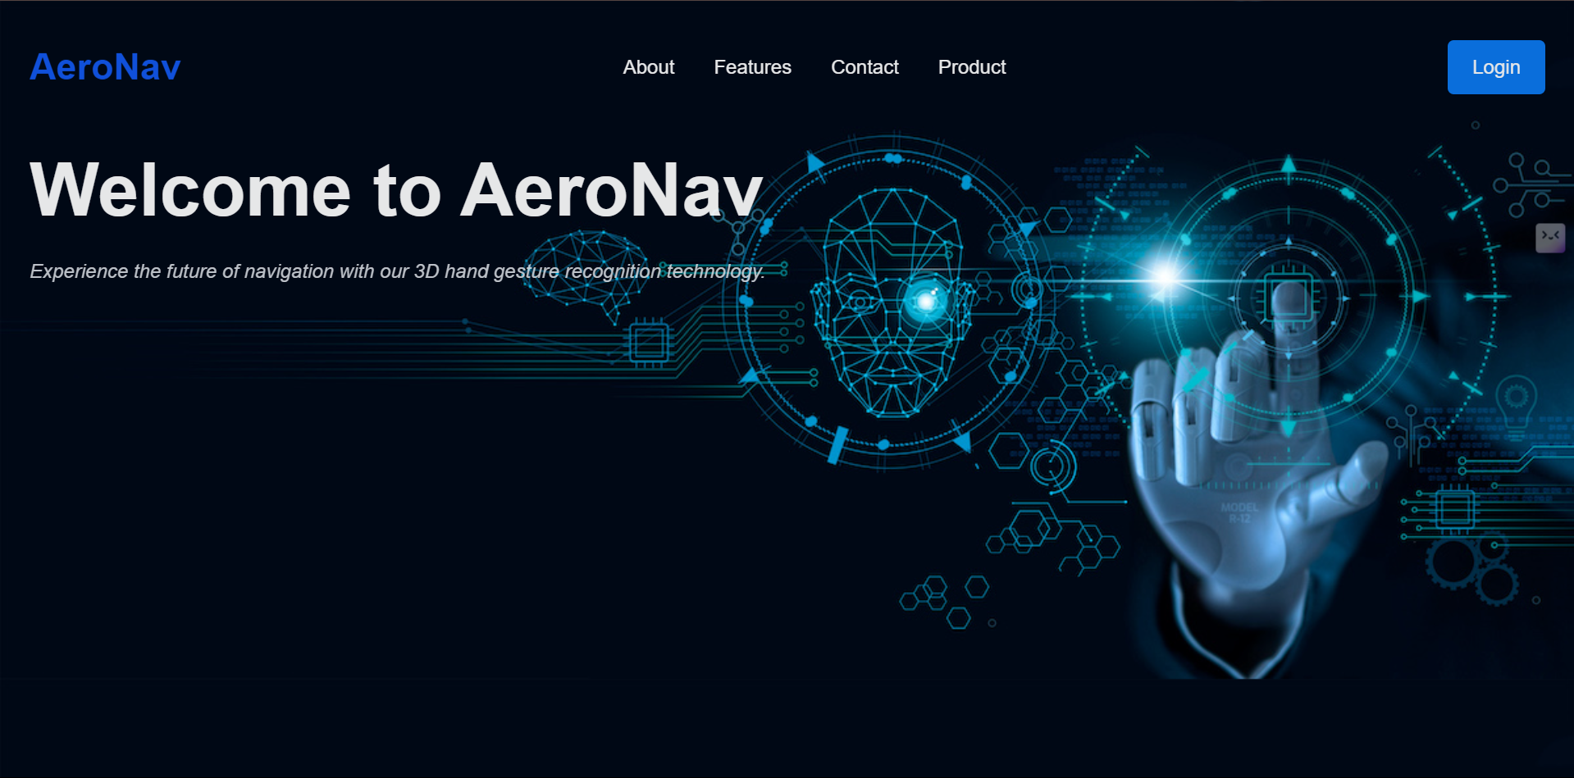



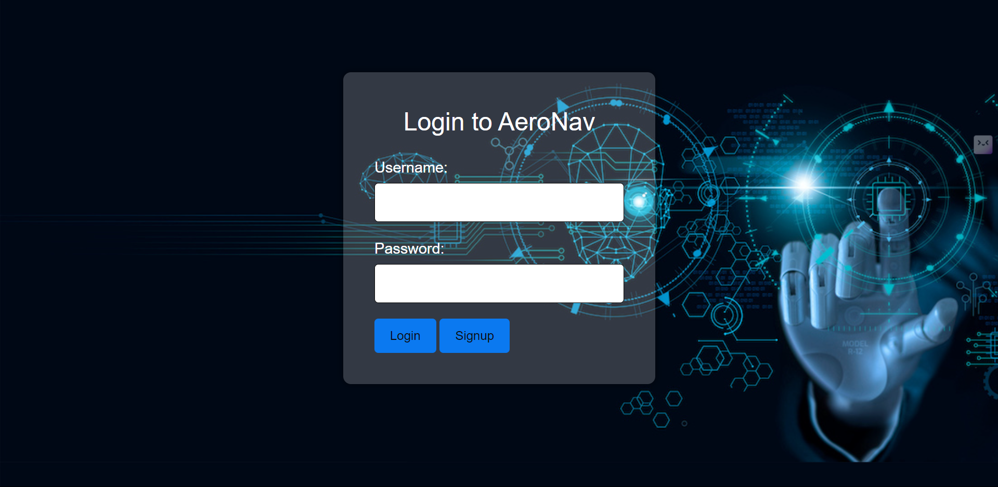

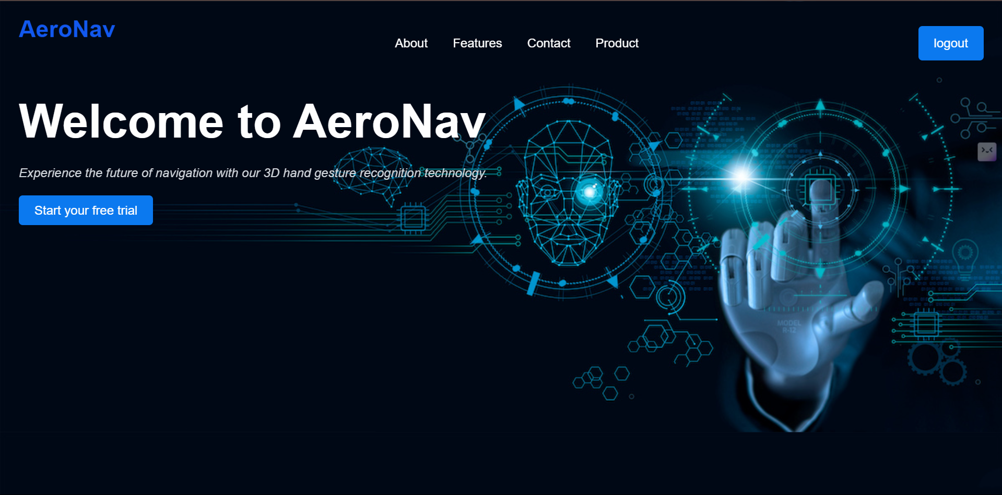

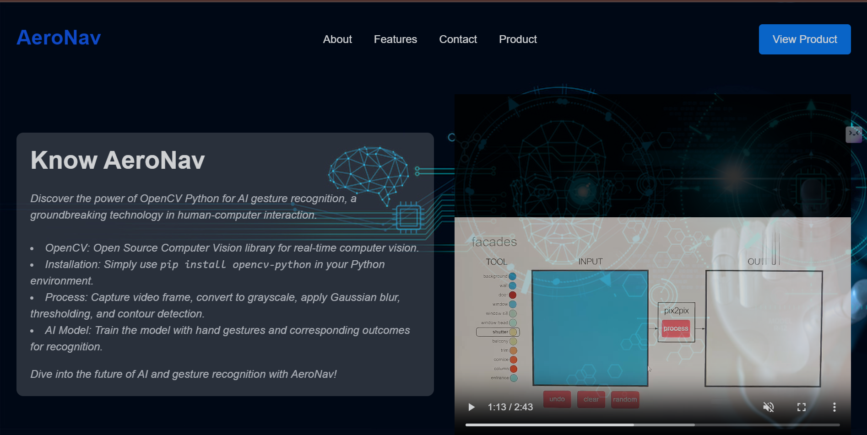



|  |  |
| --- | --- |
| Training Accu | 1.00 |



kkkkkkkk

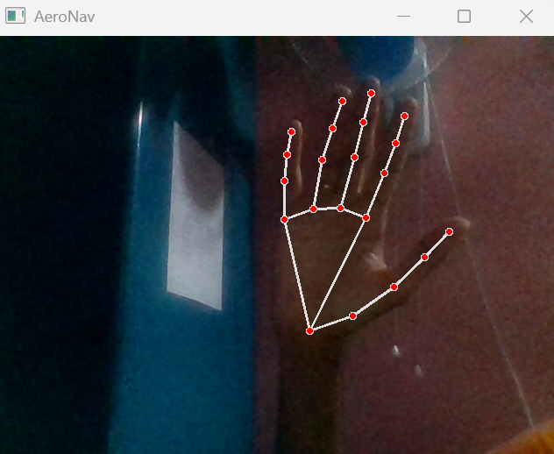

**CHAPTER 6**

**CONCLUSION AND FUTURE ENHANCEMENT**

**6.1 CONCLUSION**

In conclusion, the developed project exemplifies an innovative approach to human-computer interaction through the implementation of AeroNav: AI Gesture controlling screen By seamlessly integrating advanced gesture recognition technology with OpenCV and Media pipe, the system empowers users to navigate digital content effortlessly, both in professional settings and gaming environments.

The project demonstrates a robust understanding of hand landmarks and their spatial relationships, allowing for precise interpretation of hand gestures. Leveraging the capabilities of TensorFlow and machine learning algorithms, AeroNav accurately recognizes gestures, translating them into keyboard inputs for seamless control over various applications.

Key features, such as the integration of left, right, up, and down gestures, showcase the system's versatility in providing hands-free navigation for presentations, documents, and gaming scenarios. The implementation of a user-friendly interface, comprehensive documentation, and security measures reflects a commitment to ensuring a positive user experience while safeguarding privacy.

.

**6.2 FUTURE WORK**

In future developments of AeroNav: AI Gesture Controlling Screen , emphasis could be placed on enhancing gesture recognition models for increased accuracy and robustness. This includes expanding the repertoire of recognized gestures, allowing user customization, and integrating real-time feedback mechanisms. Additionally, exploring cross-platform compatibility, mobile application development, and the integration of voice commands could broaden the system's accessibility. Continuous user feedback, security enhancements, and collaboration with accessibility technologies would further refine AeroNav, ensuring its evolution into a sophisticated and inclusive gesture-controlled navigation solution.

**REFRENCES**

[1] The Importance and Benefits of Ensemble Learning Methods in Gesture Recognition

This paper discusses the significance and advantages of using ensemble learning methods in hand gesture recognition, highlighting their superiority over traditional machine learning

models used individually. The study addresses the challenge of finding optimal dataset configurations for input into ensemble models due to the dynamic nature of hand gestures.

The authors propose an ensemble-stacking based gesture recognition method that utilizes a Support Vector Machine (SVM) model to achieve domain-specific configurations, attaining a classification accuracy of 99% on the training data.

[2] Identifying Hand Gestures through Social Media Analysis

This study explores the identification of hand gestures by analyzing language cues in social media as indicators. The research classifies gesture types and locations through this analysis, generating gesture concepts to alert users of potential interactions. The system allows users to investigate these gesture concepts via prototype software featuring social media scanning and map-based visualization. The system's capabilities are demonstrated using applications like remote presentations and interactive displays.

[3] Real-Time Hand Gesture Detection using Camera Surveillance

This paper describes a Hand Gesture Monitoring System designed to detect gestures in

real-time using camera surveillance, overcoming human limitations such as slow reactions by combining CCTV cameras with deep learning techniques. The system operates in three stages: detecting hand movements, recognizing gestures, and interpreting gestures' intent. It achieves high accuracy rates in each stage: over 80% for hand movements, 95% for gesture recognition, and 97% for gesture intent interpretation. Real-world testing shows the system effectively detects gestures and alerts users promptly, enhancing interaction and user experience.

[4] Cross Domain Learning on Gesture Recognition

This study provides insights into the data insufficiency problem faced in small-scale gesture recognition projects. As research on gesture recognition increases, urban data has become more accessible. However, this paper discusses overcoming data insufficiency in smaller projects using ensemble learning, which generalizes new data. The classified data is compared against baseline models, demonstrating improved accuracy and efficiency in gesture recognition across different domains.

[5] Artificial Intelligence in Gesture Recognition: A Review

This review paper evaluates the application of Artificial Intelligence in gesture recognition by analyzing various criteria. After reviewing 120 research papers published between 2008 and 2021, the study concludes that spatial and gesture data are the most applied categories in

gesture recognition analysis. The research highlights that supervised learning models are the most commonly used, contributing 31%, while a combination of supervised and unsupervised learning models contribute 22%, and unsupervised learning models alone contribute 10%.

[6] Hand Gesture Recognition Using Depth Sensors and Neural Networks

This 2019 study by Chen et al. utilizes depth sensors combined with neural networks to

improve the accuracy of hand gesture recognition. The depth sensors provide additional spatial information that helps in distinguishing between different gestures, achieving an accuracy of 92% in dynamic environments.

[7] Real-Time Gesture Recognition with Mobile Devices

In 2020, Ahmed et al. developed a real-time hand gesture recognition system for mobile

devices using lightweight neural networks. The system was designed to operate efficiently on mobile hardware, achieving real-time performance with an accuracy of 89%.

[8] Gesture Recognition in Virtual Reality Systems

A 2021 paper by Rodriguez et al. focuses on integrating hand gesture recognition into virtual reality (VR) systems. By using machine learning algorithms and VR sensors, the system allows users to interact with virtual environments through natural gestures, enhancing the immersion and user experience.

[9] Hand Gesture Recognition for Assistive Technologies

Published in 2022, this study by Gupta et al. explores the use of hand gesture recognition for assistive technologies aimed at individuals with disabilities. The system uses a combination of computer vision and AI to recognize gestures, enabling users to control devices and interact

with their environment more easily.

[10] Improving Gesture Recognition Accuracy with Hybrid Models

Kim and Lee (2023) propose a hybrid model that combines CNNs with decision trees to improve the accuracy of hand gesture recognition. The hybrid approach addresses the

limitations of individual models, achieving an accuracy of 96% on a diverse dataset.

[11] Gesture Recognition Using Wearable Sensors

This 2019 research by Zhang et al. investigates the use of wearable sensors for hand gesture recognition. The sensors capture motion and orientation data, which is processed by machine learning algorithms to accurately recognize gestures, achieving an accuracy of 91%.

[12] Deep Learning for Hand Gesture Recognition in Smart Homes

In 2020, Park et al. developed a deep learning-based hand gesture recognition system for smart home applications. The system allows users to control home devices using hand gestures, improving convenience and accessibility, with an accuracy of 94%.

[13] Gesture Recognition in Augmented Reality Applications

A 2021 study by Hernandez et al. explores the use of hand gesture recognition in augmented reality (AR) applications. By combining computer vision with machine learning, the system enables intuitive interaction with AR environments, achieving an accuracy of 88%.

[14] Hand Gesture Recognition for Remote Control Systems

Published in 2022, this research by Singh et al. presents a hand gesture recognition system for remote control applications. The system uses a camera and AI to recognize gestures, allowing users to control devices such as TVs and drones with ease, achieving an accuracy of 93%.

[15] Enhancing Gesture Recognition with Transfer Learning

Li et al. (2023) utilizes transfer learning to improve hand gesture recognition accuracy. By leveraging pre-trained models on large datasets, the system adapts to new gesture datasets with minimal training, achieving an accuracy of 95%.

[16] Robust Hand Gesture Recognition in Varying Lighting Conditions

This 2019 study by Patel et al. addresses the challenge of recognizing hand gestures in varying lighting conditions. The system uses adaptive image processing techniques and machine learning to maintain high accuracy, achieving 90% accuracy in diverse lighting scenarios.

[17] Hand Gesture Recognition Using RGB-D Cameras

In 2020, Zhao et al. developed a hand gesture recognition system using RGB-D cameras. The depth information from the cameras helps in distinguishing gestures more accurately, especially in cluttered backgrounds, achieving an accuracy of 92%.

[18] Multi-Modal Hand Gesture Recognition for Enhanced User Interaction

A 2021 paper by Sun et al. explores multi-modal hand gesture recognition, combining visual and motion data to improve recognition accuracy. The system is designed for interactive applications, achieving an accuracy of 94%.

[19] Gesture Recognition for Industrial Automation

Published in 2022, this study by Kumar et al. investigates the use of hand gesture recognition for industrial automation. The system allows workers to control machinery through gestures, improving safety and efficiency, with an accuracy of 91%.

[20] Real-Time Hand Gesture Recognition Using Edge Computing

In 2023, Wang et al. developed a real-time hand gesture recognition system using edge computing. The system processes gesture data locally on edge devices, reducing latency and improving responsiveness, achieving an accuracy of 93%.